**Advance DevOps lab**

**Experiment 2**

**Name: BALOCH MUZAMMIL HAFEEZ ROLL NO: 612012**

**Semester: V**

**Branch: Information Technology**

1. **What is S3? Explain Uses of S3.**

Ans: Amazon S3 is an object storage service that provides industry-leading scalability, data availability, security, and performance. Customers of all sizes and sectors may store and protect nearly any amount of data for use cases such as data lakes, cloud-native applications, and mobile apps. You may optimise expenses, organise data, and establish fine-tuned access restrictions to suit specific business, organisational, and compliance requirements using cost-effective storage classes and simple management tools.

S3 provides the following functionalities:

1. Build a data lake:

To gain data insights, use big data analytics, artificial intelligence (AI), machine learning (ML), and high-performance computing (HPC) applications.

1. Backup and restore critical data:

Meet Recovery Time Objectives (RTO), Recovery Point Objectives (RPO), and compliance requirements with S3’s robust replication features.

1. Archive data at the lowest cost:

Move data archives to Amazon S3 Glacier storage classes to reduce expenses, simplify operations, and acquire new insights.

1. Run cloud-native applications:

Create cloud-native mobile and web apps that scale automatically in a highly available configuration.

1. **Deployment of static web site on AWS S3.**

Step 1: Management Console Dashboard.

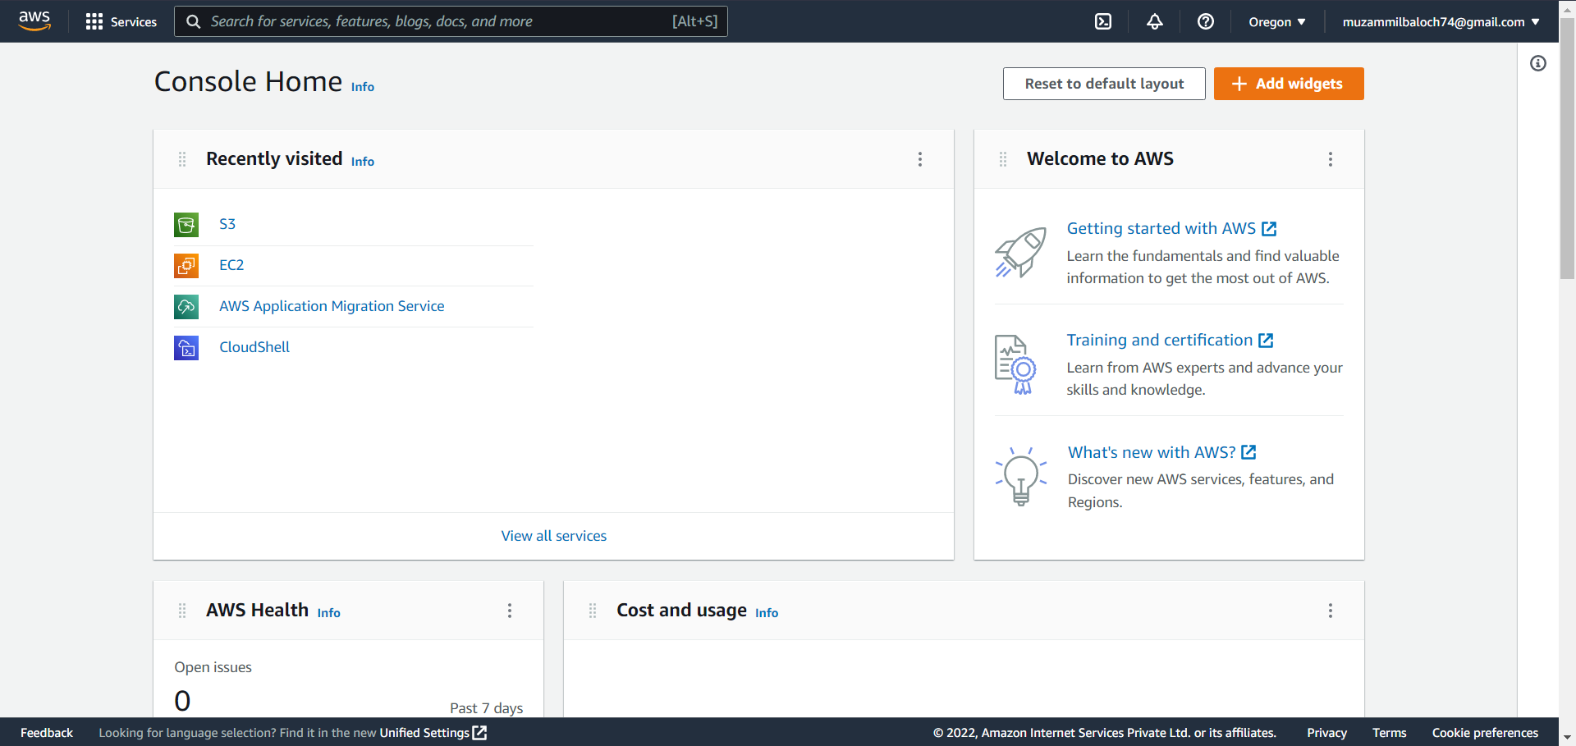

Step 2: Click on services and then click on S3.

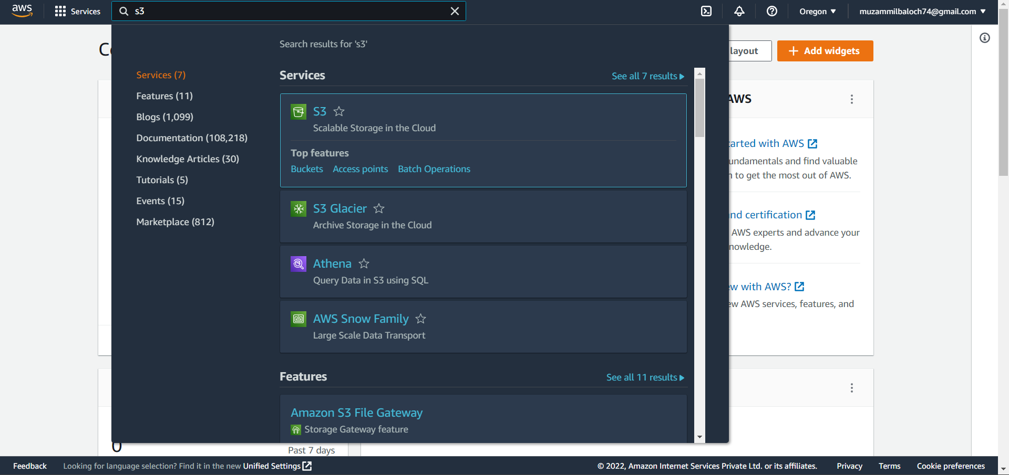

Step 3: Create a bucket.

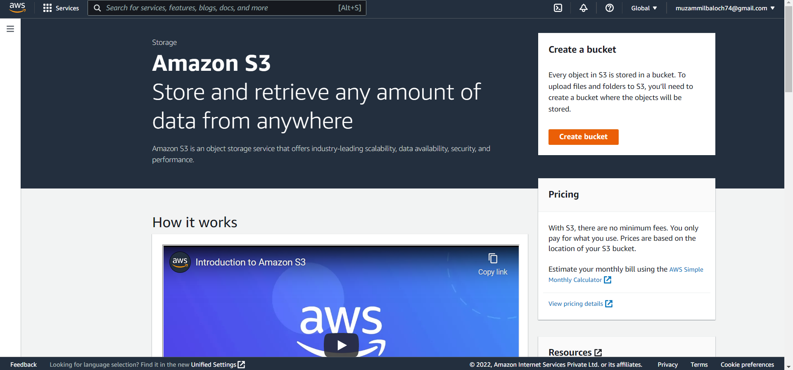

Step 4: Name the bucket.

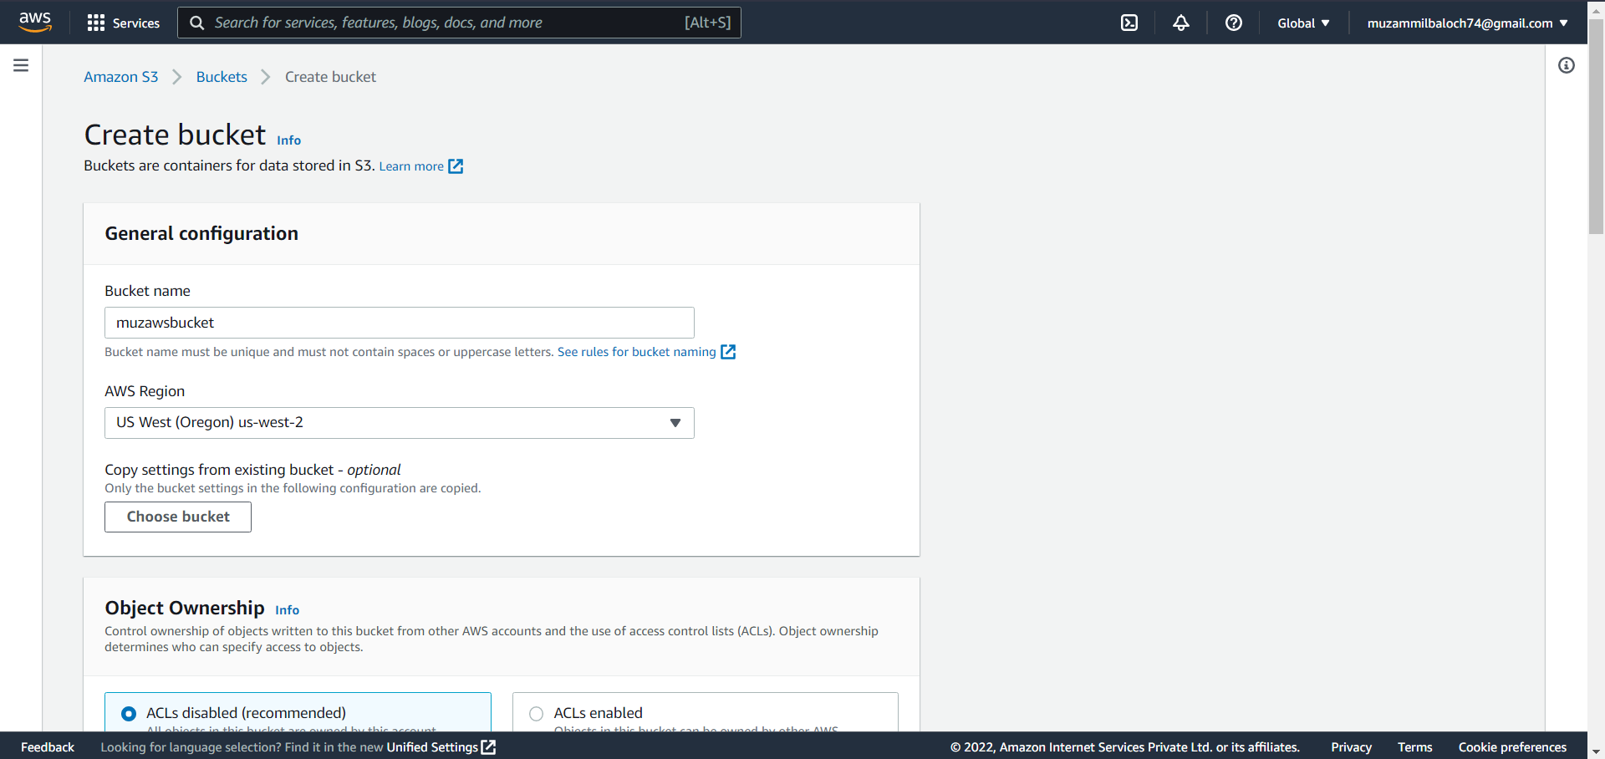

Step 5: Unblock and recognise all public access.

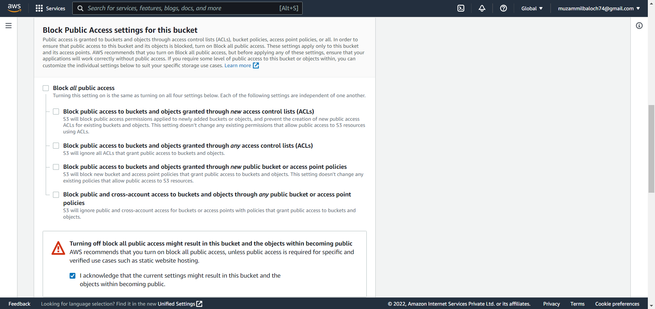

Step 6: Review the settings and make the bucket.

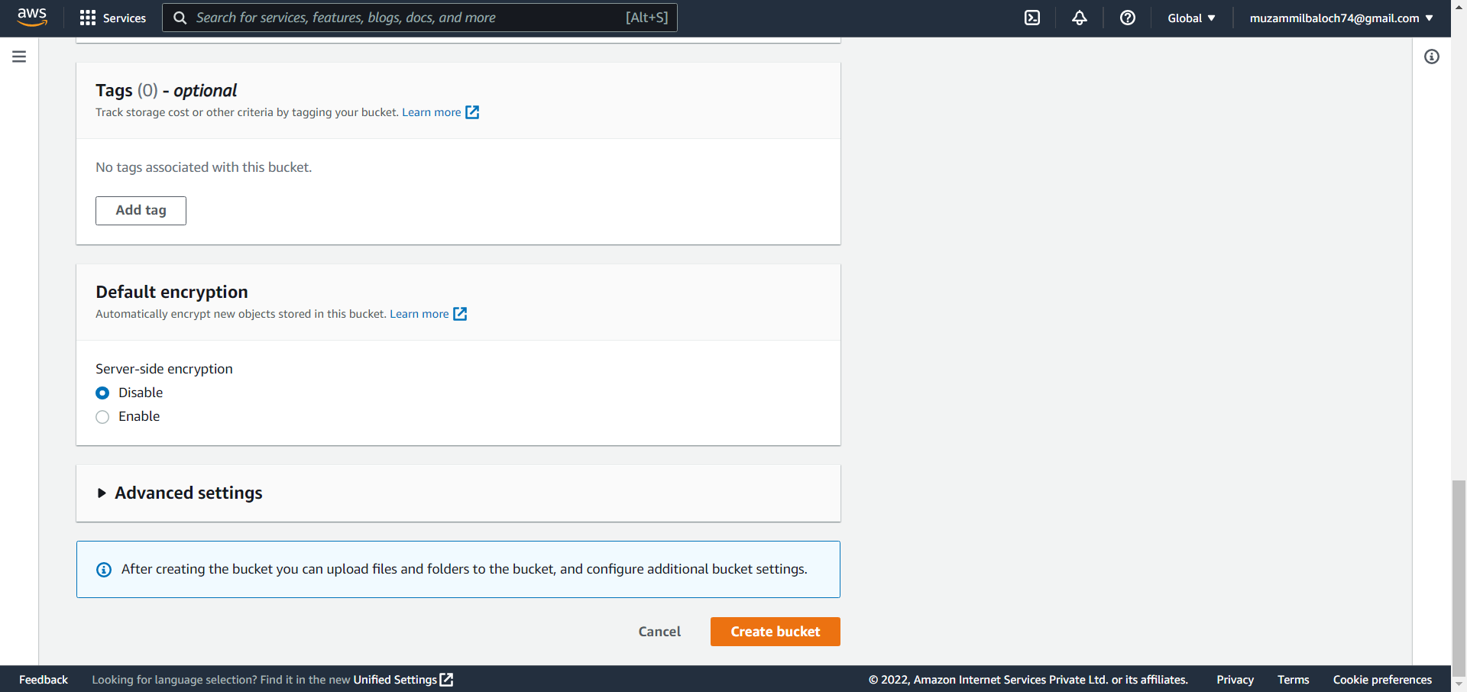

Step 7: select the bucket you have created.

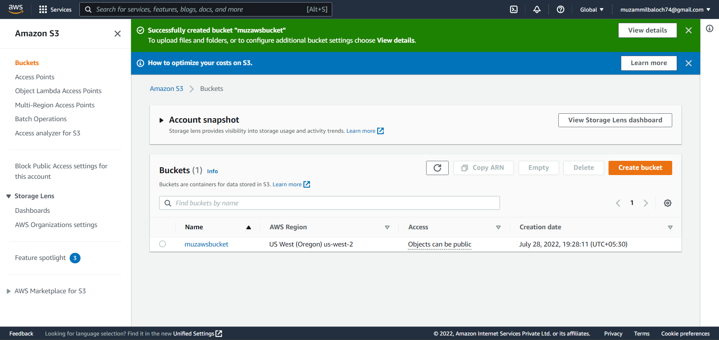

Step 8: Navigate to permissions and edit bucket policy.

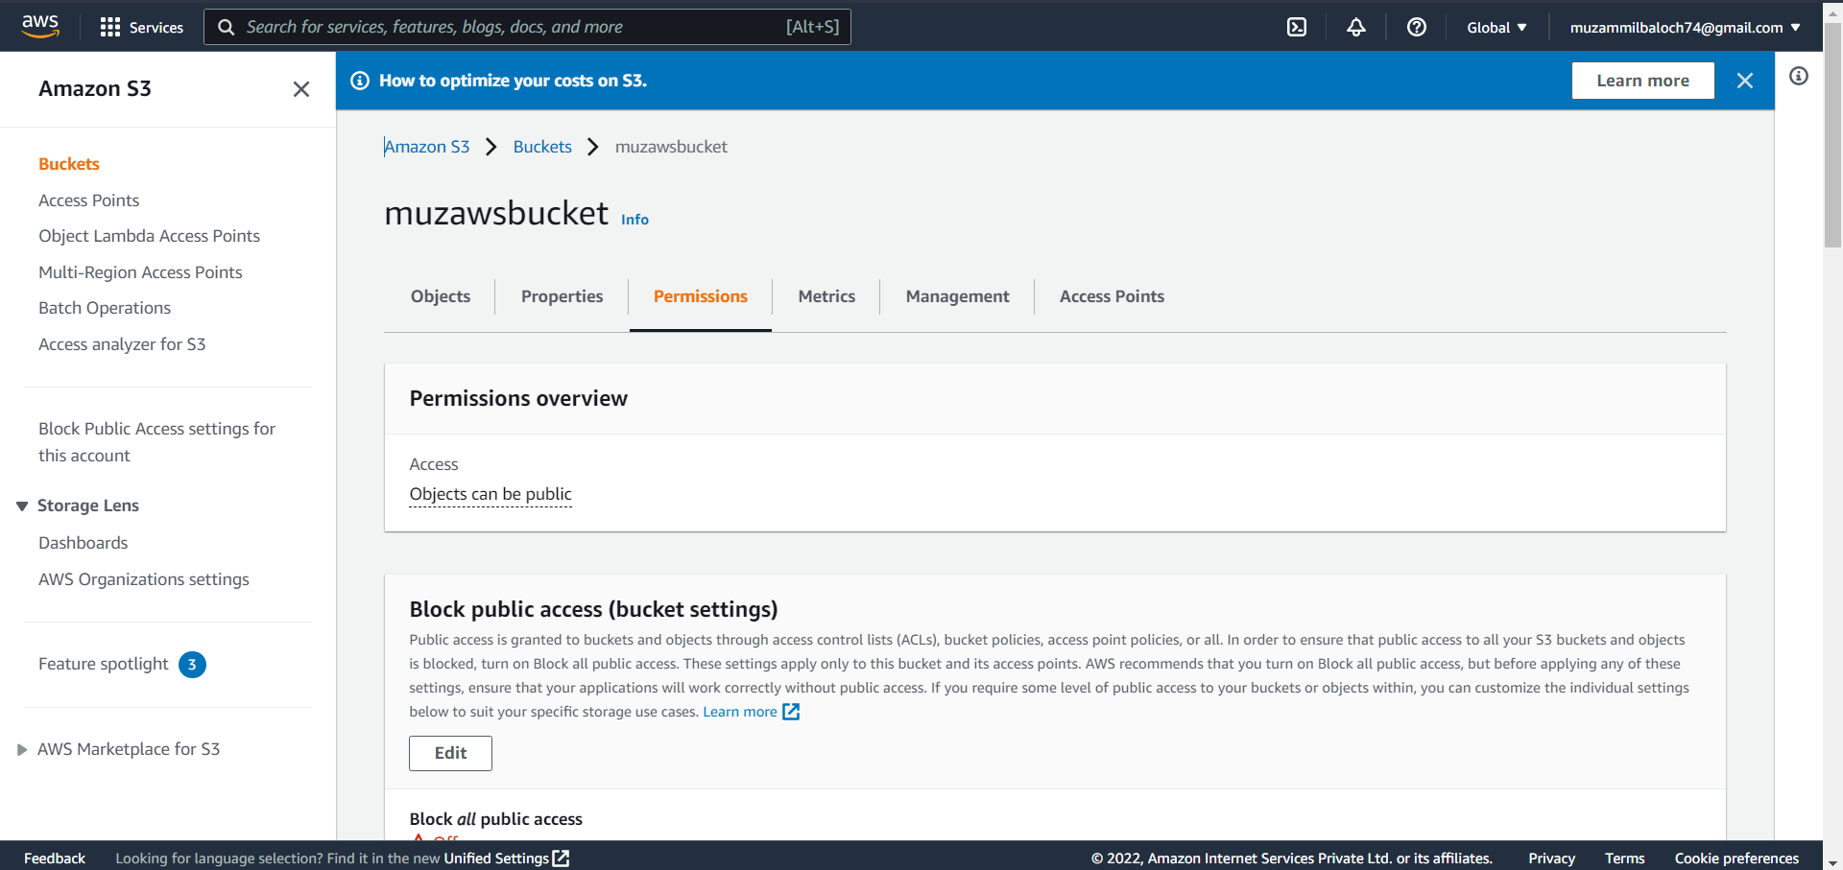

Step 9: Save the modifications after changing the policy to bucketpolicy22.

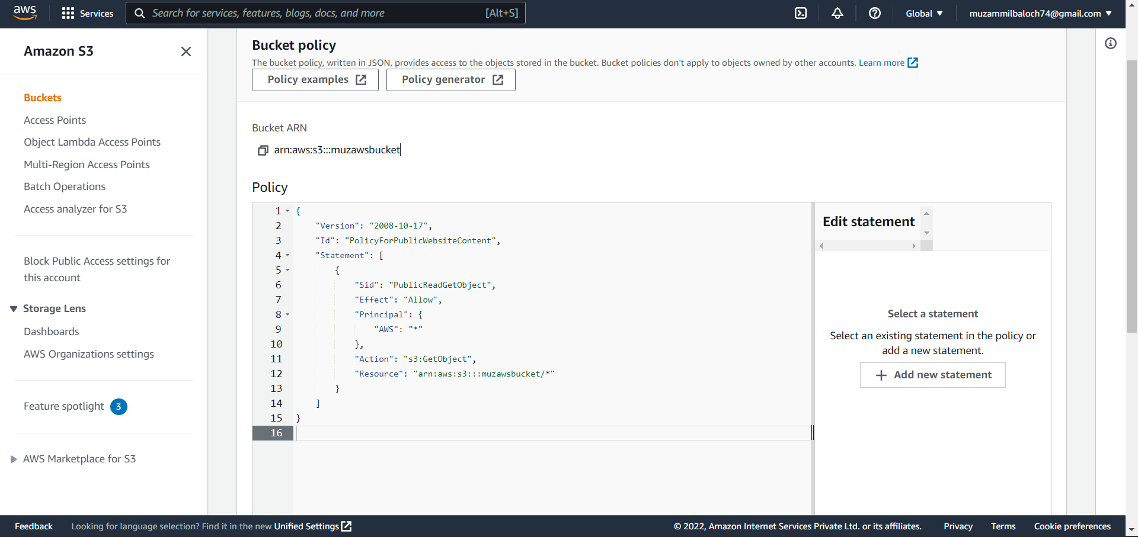

Step 10: Upload an index in HTML format under objects.

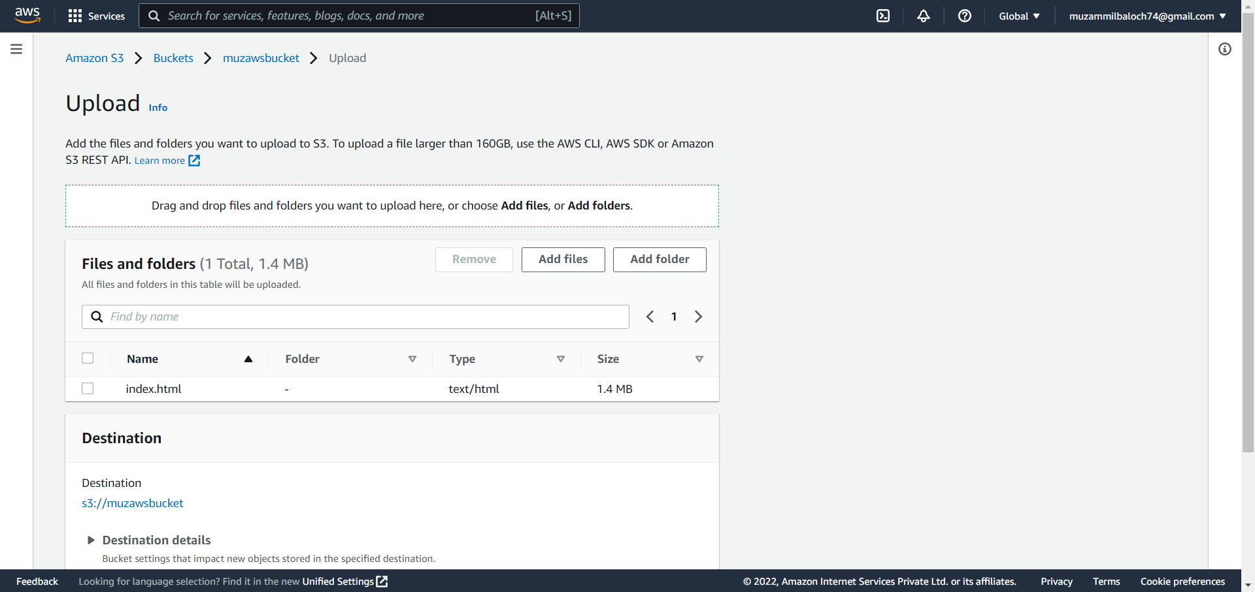

Step 11: Go to Properties, enable Static Website Hosting, and then upload the index file.

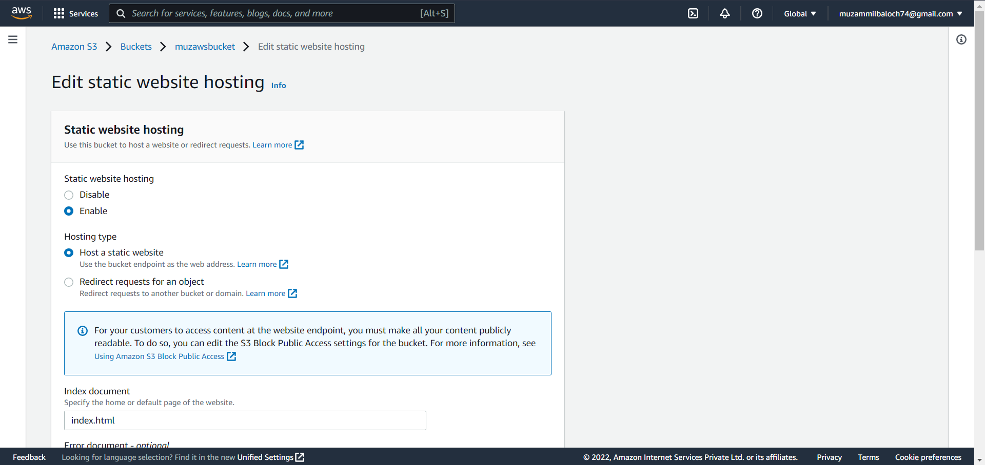

Step 12: Now a link to your website will be available at the bottom of the Properties section.

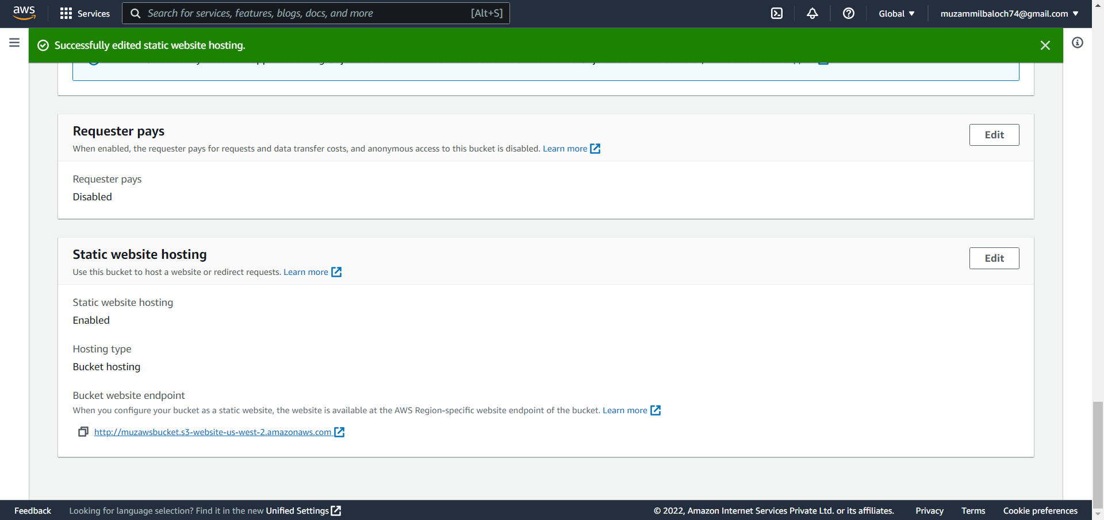

Step 13: Anyone with the URL can now visit your website.

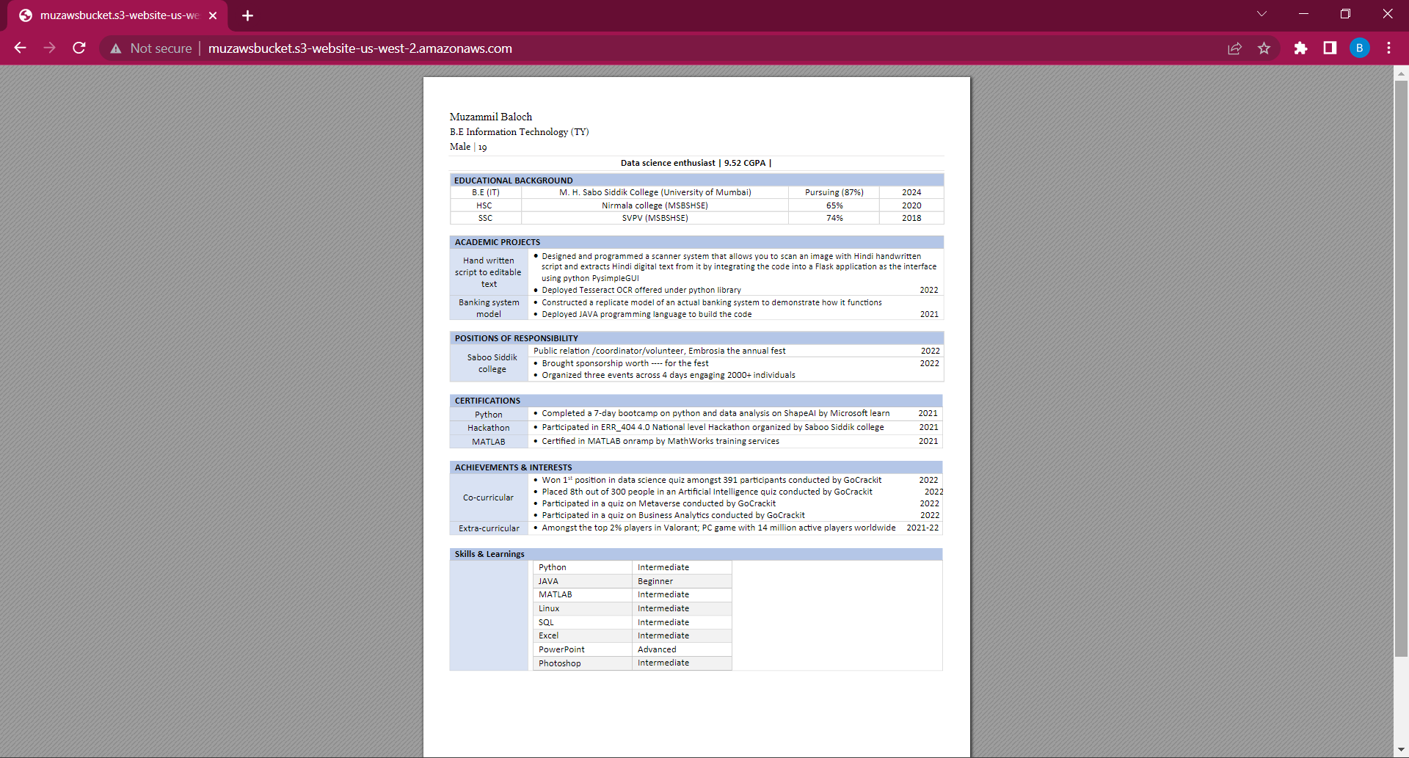

Step 14: Delete every object.

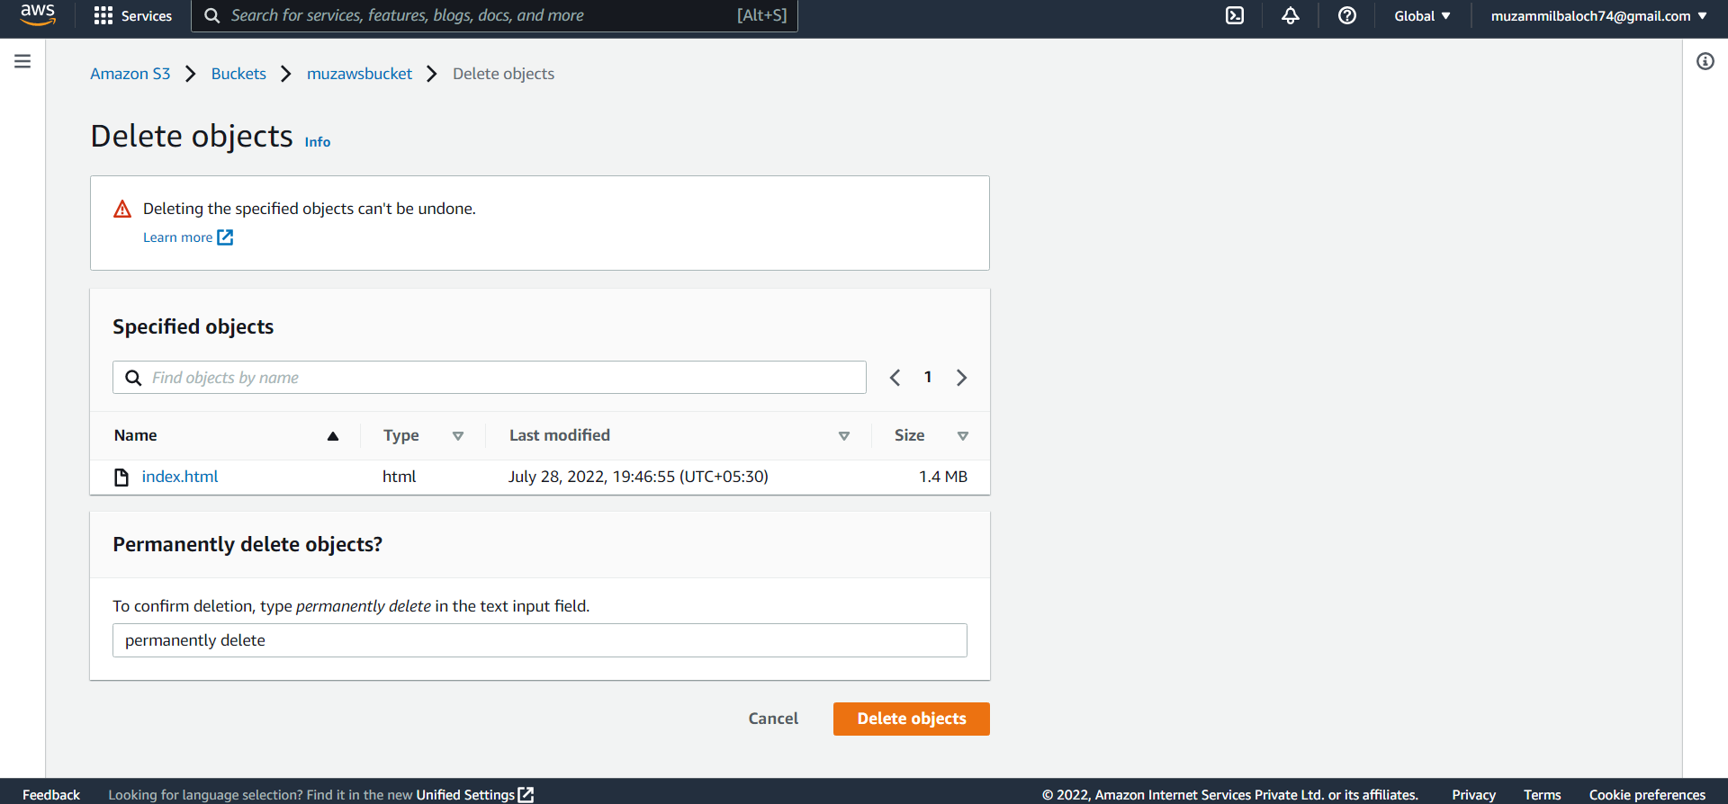

Step 15: After you've removed all of the objects, delete the bucket as well.

